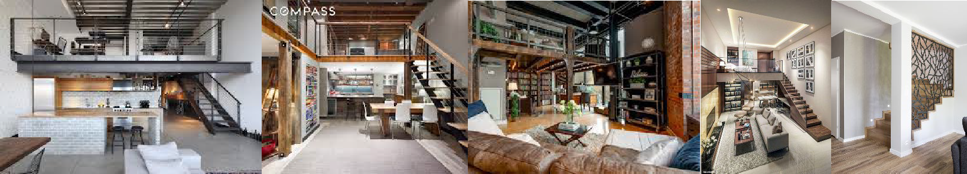
Topic: Assignment 9: Furniture Plan
Objective: to help students understand the concept of shaping interior space using furniture related to movement and activities unique to Residential spaces.
Assignment 9 – Create a Furniture Plan
- Utilizing your floor plan, begin shaping your residential spaces using specified furniture pieces unique to the activities in those spaces.
- Students should sketch out multiple variations of furniture placement before landing on a layout that works in terms of function and form.
- Final layouts should integrate a circulation pattern that seamlessly leads from one space to another (Wayfinding Concepts).
- Through the design of the space, spatial relationships should be evident.
Be sure to include the following:
- _____/30 All furniture needed to accomplish the activity that occurs in space.
- _____/05 Label all rooms and spaces.
- _____/05 Indicate Ceiling height for all rooms and multiple times large open areas.
- _____/15 Correctly note the staircase with up and down arrows.
- _____/10 Articulate theoretical design applications.
- _____/05 Poche walls for clear articulation of space.
- _____/05 Note all flooring and any floor changes or ramps where applicable.
- _____/10 Indicate all significant components such as fireplaces, all built-in furniture, appliances, and plumbing fixtures, and label them.
- _____/05 Note any miscellaneous items, such as specialty items associated with a particular design application (i.e., kitchen and bath accessories items, specialty closets, and closet accessories).
- _____/10 Make sure that all drawings are clear and legible.

Total _____/100

